**Nama : Mirza Priscilla Faradiba**

**Kelas : VSGA JWD-B Polinema**

**Tugas : Pertemuan 13**

Buatlah sebuah website input data dan menampilkanya dengan menggunakan MYSQL,PHP dan HTML dengan tampilan berikut

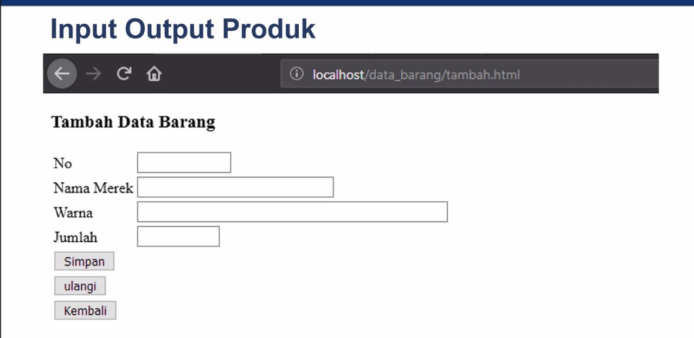

**Jawab :**

**Kode Program**

* **Index.html**

<!DOCTYPE html>

<html>

<head>

    <title>Tambah Data Barang</title>

</head>

<body>

    <h1>Tambah Data Barang</h1>

    <form action="simpan.php" method="POST">

        <label for="no">No:</label>

        <input type="text" name="no" id="no" required><br><br>

        <label for="nama_merek">Nama Merek:</label>

        <input type="text" name="nama_merek" id="nama_merek" required><br><br>

        <label for="warna">Warna:</label>

        <input type="text" name="warna" id="warna" required><br><br>

        <label for="jumlah">Jumlah:</label>

        <input type="number" name="jumlah" id="jumlah" required><br><br>

        <input type="submit" value="Simpan">

        <input type="reset" value="Ulangi">

        <button onclick="goBack()">Kembali</button>

        <script>

            function goBack() {

                window.history.back();

            }

        </script>

    </form>

    <br>

    <a href="tampil.php">Lihat Data Barang</a>

</body>

</html>

* **Simpan.php**

<?php

// Koneksi ke database

$host = 'localhost';

$user = 'root';

$password = '';

$database = 'data';

$conn = mysqli_connect($host, $user, $password, $database);

if (!$conn) {

    die("Koneksi database gagal: " . mysqli_connect_error());

}

// Mengambil data dari form

$no = $_POST['no'];

$namaMerek = $_POST['nama_merek'];

$warna = $_POST['warna'];

$jumlah = $_POST['jumlah'];

// Menyimpan data ke database

$sql = "INSERT INTO printer (no, nama_merek, warna, jumlah) VALUES ('$no','$namaMerek', '$warna', '$jumlah')";

if (mysqli_query($conn, $sql)) {

    echo "Data berhasil disimpan.";

} else {

    echo "Terjadi kesalahan: " . $sql . "<br>" . mysqli_error($conn);

}

mysqli_close($conn);

?>

* **Tampil.php**

<?php

// Koneksi ke database

$host = 'localhost';

$user = 'root';

$password = '';

$database = 'data';

$conn = mysqli_connect($host, $user, $password, $database);

if (!$conn) {

    die("Koneksi database gagal: " . mysqli_connect_error());

}

// Mengambil data barang dari database

$sql = "SELECT * FROM printer";

$result = mysqli_query($conn, $sql);

echo "<h1>Data Barang</h1>";

echo "<table border='1'>

    <tr>

        <th>No</th>

        <th>Nama Merek</th>

        <th>Warna</th>

        <th>Jumlah</th>

    </tr>";

while ($row = mysqli_fetch_assoc($result)) {

    echo "<tr>";

    echo "<td>" . $row['no'] . "</td>";

    echo "<td>" . $row['nama_merek'] . "</td>";

    echo "<td>" . $row['warna'] . "</td>";

    echo "<td>" . $row['jumlah'] . "</td>";

    echo "</tr>";

}

echo "</table>";

mysqli_close($conn);

?>

**Hasil**

